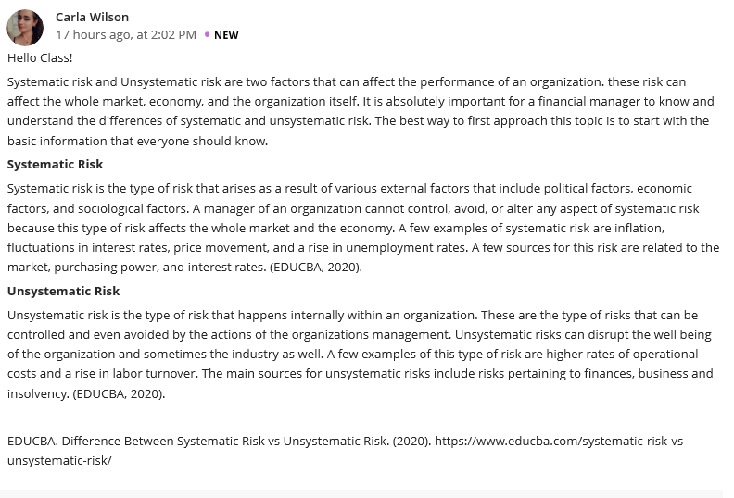
Hello Wilson.
I absolutely agree with you point of view, as an aspect that occurs due to Macroeconomic factors, Systematic risk can be understood to be an aspect that’s beyond the control of a specific company or individual and hence can’t be diversified .Consequently, its significant to note that all Investments and securities suffer from such type of risk. One can’t eliminate such a risk by holding more number of shares. To an Individual who probably might have Issues with the topic ,I would recommend that the best approach to approach this topic is by first understanding this risk include all the unforeseen events that happen in everyday life, thus, making it beyond the control of the investors. Furthermore, systematic risk impacts the entire industry rather than a single company or security. When compared to Unsystematic risks, the organization can be able to strategize to tackle such risks as compared to systematic risks which an organization has got not control.
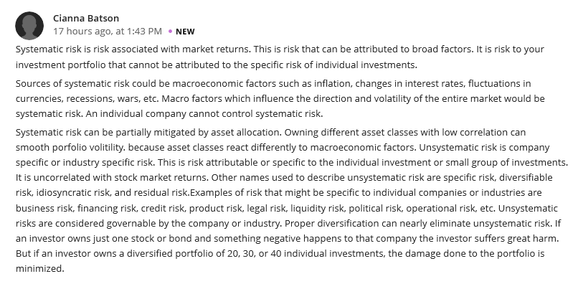
Hello Batson!
Great post!, just to comment on what you have already highlighted, as risk that’s associated with market returns, systematic risk is a loss associated with the entire market or the segment. The macro economic factors such as Inflation, fluctuation in currencies have for over time played a major role increasing the systematic risk. Most companies have to battle such risk at a time when they are facing other unsystematic risk and without proper management of the company, most companies have been pushed by such situations to close up. However, its significant to note that, companies have a role to play in ensuring that they are at least able to partially mitigate such risks in a way that it doesn’t bring down most of its operations .For example, proper financial preparation can be the best tool to mitigate systematic risks. Asset allocation can partially mitigate systematic risks. Owning different asset categories (i.e. bonds, cash, commodities, etc.) with low or zero correlation helps because they reach differently to macroeconomic factors; some asset categories may increase and others may fall.
Another way to reduce systematic risk is through hedging. Investors can use options such as purchasing protective puts on their securities. A protective put is risk-management strategy that investors use to guard against the loss of unrealized gains. Put value will rise if securities value drops. However, options are for a certain time and once they expire, investors need to buy new ones to stay hedged.

